Assessment
Submit two tables or diagrams and a short discussion not exceeding 500 words
It Is a blog for market analysis
Identify a narrow research question for blog activity

Introduction – introduce the data set, the research question and the variables that are going to be discussed (50 words)
Produce a table with a long description of what it contains
Produce a graph with a long description of what it contains
Discussion of what the table shows and what the graph shows
Discuss the limitations of the data set and the methods used
Conclussion and summary (50 words)

Data I am using – India household expenditure on services and durable goods July 2014 – June 2015 72nd round
It is a national sample survey set up by the Indian govvernemnt focusing on household consumer expenditure

Question options
703 car ownership
773 ctv security equipment agaisnt class/ rural - urban
782 computer ownership agaisnt demographic
832 jewles and pearls
Rural =1 urban = 2
Research question
Is expenditure in security equipment impacted by rural/urban

Percentage of households who brought cctv systems in inida
Then break that down by rural and urban
Show with a bar chart – x axis rural and urban / y axis – what percentage have brought computers or spending showing the average amount spent on cctv
Mean and median spending for high marks or just show ownership
Can make it specific to 3 states
MPCE shows social class stands for mean per capita expenditure

Research question
How does class impact CCTV expenditure and is this represented by a rural urban divide?
Graph 1 - Scatter plot with CCTV equipment on Y axis MPCE on X axis and have it colour coded for rural urban - completed
Graph 2 – Bar chart displaying what percentage or rural/urban have brought cctv equipment (or there average spending) X – axis rural/urban Y – axis percentage of owner ship – completed

Reading notes
Wealth inequality the Indian case
- period of economic reform has led to a sharp increase in interpersonal wealth inequality wealth is concentrated in urban areas among privleged social groups
- Disparities in the owner ship of household assets
- India is among the most unequal countires in the world (chancel et al 2022)
- As of 2012 urban rural assets composed of 21% buildings whereas 44.8% for urban
- The wealthiest of urban areas are significantly wealthier than there rural counterparts
Exploration of Indian rural markets and marketing
- Aspirations of Indian rural customers are a well-furnished concrete house followed by the acquisition of land and property
- 12% of the global population resides in the Indian rural market an understanding of this market would help businesses build strategies to tap in
- Land prices are increasing exponentially it is seen as an investment avenue

How is household expenditure on CCTV security systems impacted by class segmentation and the rural/urban divide?
Introduction
In this blog I will be answering the question ‘how is household expenditure on CCTV security systems impacted by class and the rural/urban divide in India?’. I will be doing this by analysing data from the national sample survey ‘Household expenditure on services and durable goods -July 2014 – June 2015’ 72nd round. My chosen variables for this analysis are MPCE (mean per capita expenditure), CCTV sales and rurality. I chose these variables as previous literature has shown that there are large wealth disparities between rural and urban demographics in India (Anand 2023). However, 12% of the world population resides in the Indian rural market and a greater understanding of this segment is needed for businesses to effectively tap into it (Parida and Sahney 2017). I will begin this blog with a presentation of two statistical graphs followed by a short discussion of the findings and limitations of the research.

Graph 1
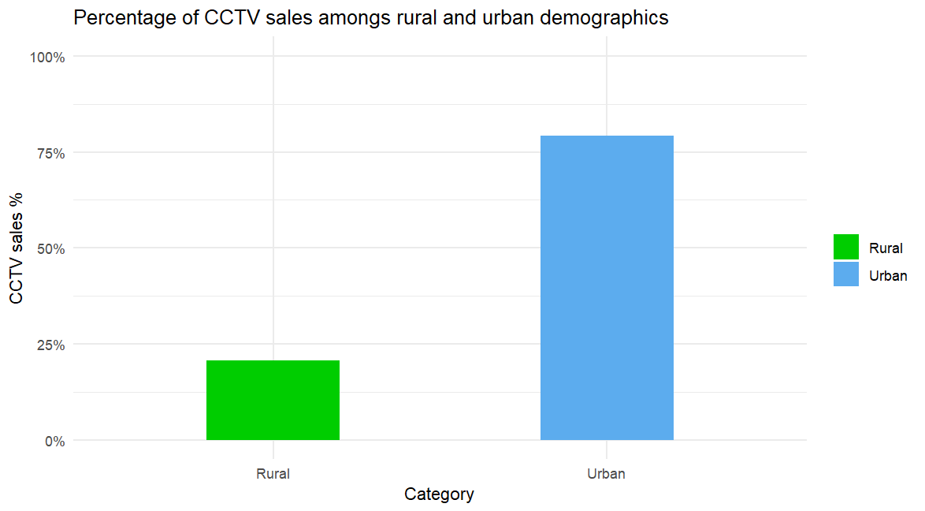
Figure 1
Figure 1 shows the percentage make up of CCTV and security expenditure among rural and urban demographics in India based on the household expenditure data set. Urban households make up 80% of all CCTV expenditure whereas rural households only make up 20% of the market share. One clear reason for this disparity as identified by Anand et al (2023) is that buildings make up a much greater proportion of urban demographics assets at over 44.8% in 2012 compared to 21% in rural demographics. This would mean that rural demographics have less need for expenditure on security systems as compared to urban demographics.
Graph 2
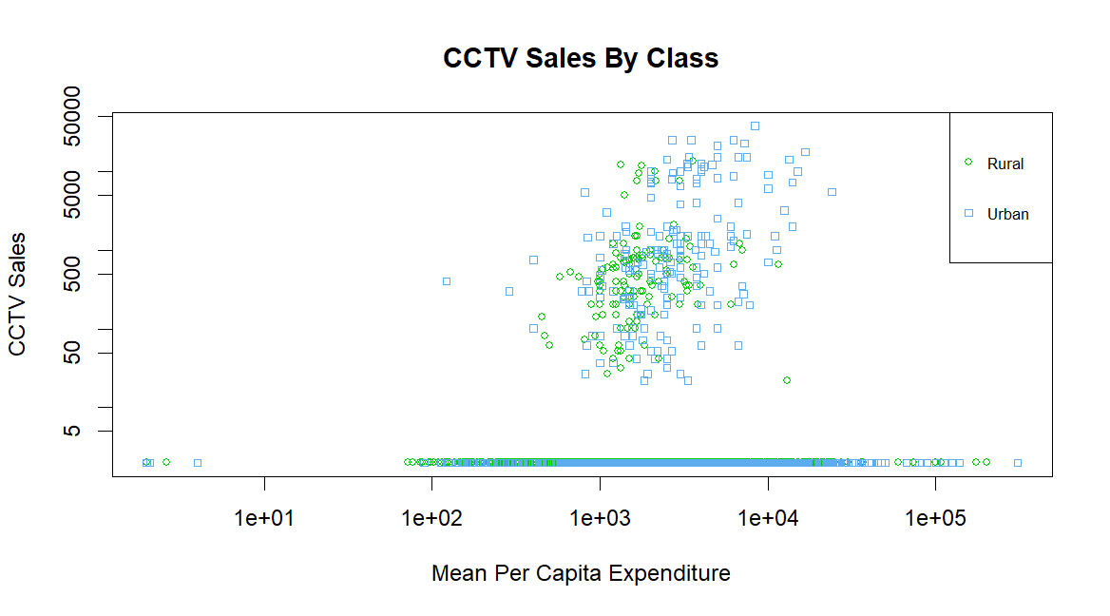
Figure 2

Figure 2 shows the levels of CCTV expenditure against mean per capita expenditure whilst also accounting for rural and urban demographics. MPCE is used to account for class as higher levels of spending indicate higher levels of wealth. Many of the plots fell on 0 expenditure so the plot had to be placed on a logarithmic scale in order to clearly identify points. This graph shows there is an observable positive correlation between higher mean per capita expenditure, CCTV expenditure and urban demographics. Research from Anand (2023) supports this showing that even rural households with high levels of expenditure pale in comparison to the wealthiest of urban households.
Limitations
However, there are some limitations of the data set and research I have conducted. One limitation is that the data is approaching 10 years in age and may no longer be as relevant to market analysts as India is rapidly developing. Furthermore, the limited scale and reach of my analysis means it fails to capture other socioeconomic causes of CCTV expenditure nor does it account for differences between states and regions within India rather taking a holistic approach.
Conclusion
Despite its limitations this analysis has shown that wealthy urban households dominate the market for CCTV and security products in India due to large wealth disparities between the demographics. However, if businesses wish to tap into the rural security market a more up to date and specific research is required.
Bibliography
- Anand, I., Thampi, A., Vakulabharanam, V. (2023). ‘Wealth inequality: the Indian case’, Canadian Journal of Development Studies, DOI: 10.1080/02255189.2023.2212898
- National Sample Survey Office, MOSPI, Government of India, (2016). ‘Household expenditure on Services and Durable goods’. Available at: India - Household expenditure on Services and Durable goods - JULY 2014 - JUNE 2015, 72 round
- Parida, R. R., Sahney, S., (2017). ‘Exploration of Indian rural markets and marketing’, Asia Pacific Journal of Marketing and Logistics, 30 (2), pp. 297-308. DOI 10.1108/APJML-12-2016-0241

